|  |  |
| --- | --- |
| **OO Analysis and Design - Final Project** | **SDH2-A**  **Laiba Asif (R00201303)**  **Shaun Milanzi (R00)**  **30/04/2023** |

Table of Contents

Hope Music Academy 2

Questions To Complete 3

Part A 4

Use Case Diagram for Hope Music Academy 4

Domain Model for Hope Music Academy 4

Class Diagram for Hope Music Academy 5

Assumption Made: 5

Chosen features for Hope Music Academy 6

Enrol a student for music lessons in a particular instrument: 6

Find the names of all current students for a particular tutor: 6

Find the names all members of a particular orchestra in a particular school playing a specific instrument: 6

Find the name of the winner of a competition: 7

Part B 8

QUESTION 1 8

QUESTION 2 10

Minutes of Meetings 12

# Hope Music Academy

The Hope Music Academy has multiple schools across Ireland. It provides a year-long education system. Its focus is on the education of students in all instruments covered from grade 1 to grade 8. The main instruments served are piano, percussion, strings, and woodwind. Each school deals with its own cohort of students and prepares them for the upcoming exams. The exams and their procedures are standardized throughout the multiple schools around the country. Each instrument is taught by several different tutors. A tutor can teach many instruments. Tuition is provided over three terms in the academic year. A term is 12 weeks duration. Each year the dates of the terms needs to be published.

Tutors are employed by the academy but assigned to teach in one school. A tutor may be qualified to tutor in more than one instrument. The qualifications of each tutor need to be managed. [ Details include name of qualification, date awarded, and awarding body]

Each school provides a loan service for instruments. An instrument can be loaned for a duration of a term. The various schools purchase instruments from suppliers approved by the head office of the main school in Limerick. At the beginning of each academic year the academy publishes details of the various instrument classes available in the different schools. Details of staff who provide tuition is also made available.

When a student wishes to enroll in a school for instrument lessons, they need to undertake an assessment. The purpose of this assessment is to assess the student’s level to place that student in the correct lesson grade for their chosen instrument. Assessments for new students are scheduled before the start of the academic year. The date and time of assessments needs to be organized. Students will be given results of their assessment. Assessing prospective students will involve two tutors. Not all assessed students will be offered a place in the school. Students who are not successful at this stage are placed on a waiting list for lessons in their chosen instrument.

Students who are successful will be offered a place and given a lesson time and the details of their tutor. Not all students will enroll when offered a place. The student will attend 1 lesson a week in a particular school room. The time of the lesson is the same each week. The duration of the lesson varies from 30 minutes to an hour depending on the grade level the student is at. lessons are based on one-to-one tuition.

Students may cancel their enrolment before commencement of first lesson and will be refunded their tuition fee. If a student does not have a satisfactory attendance they will not be allowed to progress. This will have the result of not being able to re-register the following year. They are instructed of this before classes begin. A student will not be able to progress to the next grade level in their chosen instrument if they do not achieve a satisfactory result in previous grade. Grading take place at the end of the third term each year. It is a mandatory requirement that all enrolled students take an examination at the end of the third term. They get only one opportunity to repeat a grade.

A school recital take place at the end of the year. For each instrument, the students with the highest examination grade in a particular instrument are chosen to play in the recital.

A central competition takes place annually at the main school. All schools participate. Given that there are 8 grades and that there are 5 instrument specialties, the total number of rewards will be 40. Any student can enter a competition and compete against other students playing the same instrument at a particular grade level.

Each school maintains student contact details . They also keep track of the student grades, grading information, competition winners etc.

Each school has an orchestra made up of students who have achieved a Grade 5 standard or higher on their instrument. The orchestra performs two annual concerts.

# Questions To Complete

Part A

1. Create a Use case diagram illustrating all the required functionality for the system.

2. Create a Domain Model for Hope Music Academy. Include role names, association classes and at least one self-association where appropriate.

3. Create a Design Class diagram. This classdiagramshouldcontainatleast one controller classthat is responsible for coordination all steps of each feature. Include one singleton Class. Include navigability properties for all association relationships. The design class diagram should include operations that would allow for allthe required features to be realized. To do this

i.Identify operations signatures required for its completion.

ii.Assign each operation to the appropriate class in the design model.

iii.Create Constructors for classes that require parameters in their signatures.

Chosen Features

1. Enroll a student for music lessons in a particular instrument.
2. Find the names of all current students for a particular tutor.
3. Find the names of all members of a particular orchestra in a particular school playing a specific instrument.
4. Find the name of the winner of a competition.

Part B

Question 1

Observer design pattern and the Strategy Design

1. What is the purpose of the pattern?
2. What problems does this pattern solve?
3. How is the pattern applied in the code?
4. Reverse engineer the code in each question into a class diagram.

Question 2

LoanApprovalHandler

1. Draw a class diagram to model the code.
2. Explain why the code violates the open closed principle.
3. Rewrite the code so it does not violate this design principle. iv. Draw a class diagram to model revised code.

# Part A

## Use Case Diagram for Hope Music Academy

## Domain Model for Hope Music Academy

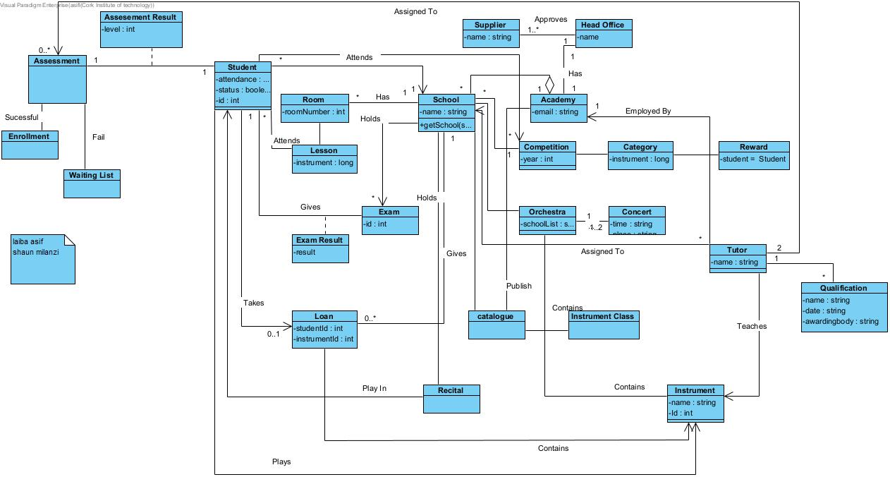

## Class Diagram for Hope Music Academy

# Assumption Made:

There may be less than five students in a singing lesson, but never more than five.

# Chosen features for Hope Music Academy

### Enrol a student for music lessons in a particular instrument:

### Find the names of all current students for a particular tutor:

### Find the names all members of a particular orchestra in a particular school playing a specific instrument:

### Find the name of the winner of a competition:

# Part B

## QUESTION 1

1. What is the purpose of the pattern?

Observer design pattern: uses three actor classes. Subject, Observer and Client. Subject is an object having methods to attach and detach observers to a client object.

Strategy Design pattern: when a client chooses the actual implementation to be utilised at runtime when we have numerous algorithms for a given task.

1. What problems does this pattern solve?

Observer design pattern: Define how one-to-many dependency between objects so that when one object changes state, all its dependents are notified and updated automatically. The key idea in this pattern is to define subject and observer objects to establish a flexible notification-registration mechanism that updates all registered observers dynamically when an event of interest occurs.

Strategy Design pattern: Strategy Pattern prevents hard-wiring of all the algorithms into the program. This makes the program complex and much more bogus and hard to refactor/maintain and understand. This makes the program to contain algorithms they do not use.

1. How is the pattern applied in the code?

Observer design pattern: The core (or autonomous, common, or engine) abstraction is represented by the word "subject." The abstraction of a variable, dependent, optional, or user interface is represented by an observer. The Observer objects are directed to act by the Subject. The Subject can be contacted by any Observer whenever necessary.

Strategy Design pattern: The interface object could reflect the client's expected method signatures or an abstract base class. The inheritance hierarchy stands in for dynamic polymorphism in the first scenario. In the latter instance, the inheritance tree stands in for static polymorphism and the Interface object for client-side template code.

1. Reverse engineer the code in each question into a class diagram:

Observer Design Pattern Class Diagram

Strategy Design Pattern Class Diagram

### QUESTION 2

1. Class diagram to model the code:

1. Explain why the code violates the open closed principle:

Once created, entities shouldn't be updated to add additional functionality; instead, the entity must be extended. In other words, expand the current modules to meet the new demand rather than changing the old modules and affecting their functionality. Code, therefore, is more extendable and less stiff and fragile. A class should be open for extension but closed for modification. The validator is not extensible and hence violates the open closed principle.

1. Rewrite the code so it does not violate this design principle:

1. Class diagram to model revised code:

# Minutes of Meetings

MEETING1

Location: Library

Date: 29/04/2023

Start Time: 14:30

Finish Time: 15:30

Attendees: Shaun Milanzi & Laiba Asif

Activity Description:

* Discussed the requirements for finishing the project.
* Discussed the different diagrams required to finish the project.
* Developed a domain model for Hope Music Academy.
* Maintained a record of what was completed to add to our log.
* Agreed to study up and view educational videos on topics we weren't familiar with in preparation for our upcoming meeting.

MEETING 2

Location: Zoom

Date: 05/04/2023

Start Time: 20:00

Finish Time: 22:00

Attendees: Shaun Milanzi & Laiba Asif

Activity Description:

* Maintained a record of what was completed to add to our log.
* Discussed which 4 of the 8 features we would complete.
* Completed our 3 features.

MEETING 3

Location: Zoom

Date: 12/04/2023

Start Time: 13:00

Finish Time: 15:00

Attendees: Shaun Milanzi & Laiba Asif

Activity Description:

* Completed our fourth feature.
* Maintained a record of what was completed to add to our log.
* Completed the class diagram and use case diagram.
* Discussed part B of the project and started with Q1.

MEETING 4

Location: Zoom

Date: 18/04/2023

Start Time: 18:00

Finish Time: 20:00

Attendees: Shaun Milanzi & Laiba Asif

Activity Description:

* Created the project report.
* Completed part B
* Exported all the VP diagrams as images for our report.